­­­

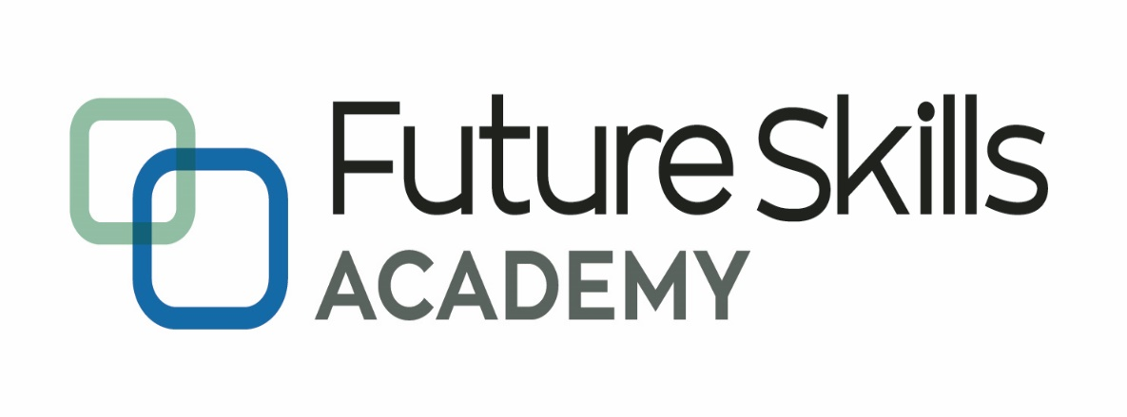

*Capable People, Capable Communities*

**Micro-Credentials in Software Development**

**Certificate in Software Development**

**MCSD51**

**Project Report**

**Zhengwen (Steven) Lei**

**Xian (Richard) Zhang**

**Maribeth Estimos**

**September 2022**

Contents

**Introduction** 3

**Initial Proposal** 3

**Variations From The Initial Proposal** 3

**Tools and Technologies Used (in alphabetical order)** 3

**SDLC** 4

**Project timeline** 4

**Ethical and cultural impact** 4

**Selected Screenshots of the completed App** 4

**Reflection** 5

**References** 7

Executive Summary

In this project, we developed a web application to generate password. We used basic HTML, CSS, Embedded JavaScript, Node.JS and JavaScript to develop this app. This is a self-sponsored, individual project developed in an iterative manner. We created the Use Cases and User Stories based on our personal knowledge and experience related to water safety.

# Introduction

As the computer knowledge developed in these years, many of the websites intend to save some personal data and we are made to login with a password. Once our password was got by wicked people, all of our relevant personal data would be potentially risk. Sometimes we have to suffer money loss if these apps related with purchasing or are likely to involve in ID frauds.

In order to prevent the password easily guessed out, these websites have various requirements for password. For example, some websites asked for a password include alphabets and numbers, with a minimum length of 8; another website may need a password include alphabets, numbers, and special symbols with minimum length of 10. Although these requirements dramatically increase the security of the password, it enhances the difficulty for us to create appropriate password.

Furthermore, these complex passwords are difficult to remember. As a consequence, many of us intend to create the same password for all of Apps or websites. This behaviour introduces an extra risk that whenever one of the Apps/websites didn’t protect well our password, all of the data in other Apps/websites are exposed.

For the purpose of helping people from creating ideal password, we decided to develop this software.

# Initial Proposal

**Preface**

It is a great opportunity for us to have the Certificate in Introductory Software Development Level 5 (MCSD51) with Future Skills Academy.

In the accomplishment of this course we are submitting a system proposal on “Password Generator”. Subject to the limitation of time, every possible attempt has been made to study and discussed the project deeply.

The whole project is measured through questionnaire, data and other vital information that were further analyzed and interpreted and the result was obtained.

The whole project has been divided into 2 parts:

**Part1: System Proposal**

‣ Introduction

‣ User Stories and use cases

‣ Ethical and cultural impact

‣ Project Timeline

‣ Diagram

**Part 2: Product Implementation**

**Contents**

Preface ………………………………………………………………………………….……2

Introduction …………………………………………………………………………….…... 4

User Stories and use cases………………………………………………………………..… 6

Ethical and cultural impact ………………………………………..………………………... 8

Project Timeline………………………………………………………………….…..…….. 9

Diagram…………………………………………….………………….…………….…….. 11

References ………………………………………………………………………………... 12

**Password Generator**

**Introduction**

The most prevalent way hackers can break through computers is by guessing your password. By using simple and common passwords creates an opportunity for hackers to get access to your electronic devices. Since no one would wish to have their personal information stolen, it is just ideal to use a strong passwords to protect your information.

Many people think good password management is all about creating difficult passwords from password generator Google. However, this is not the case. Creating a password is just the start of the management process. For instance, it is advisable to change passwords every three months. Due to the many passwords, you may need to record them on a notebook that you will carry everywhere you go.

With manual management, you might end up being mixed up by your passwords. At times, you may have to create own manual passwords that might be weak and predictable. In case the notebook is lost, all the credentials will get lost. To avoid these challenges, get a password generator that will help safeguard and manage your passwords use.

**What is a Password Generator?**

A password generator is a software tool that creates random or customized passwords for users. It helps users create a stronger password that provide greater security for a given type of access. Some password generators are simply random password generators. These programs produce complex/strong passwords with combinations of numbers, uppercase and lowercase letters, and special characters such as braces, asterisks, slashes, etc.

Other types of password generators are made to generate more recognizable passwords rather than a completely random set of characters. There are tools for generating pronounceable passwords, as well as custom tools that allow users to set detailed criteria. For instance, a user could set a request for a certain number of characters, a certain mix of letters and numbers, a certain number of special characters, or any other criteria for generating a new password.

**Objective**

Password generators help those who have to constantly come up with new passwords to ensure authorized access for programs and to manage a large number of passwords for identity and access management. Other kinds of tools include a password vault, where users manage large numbers of passwords in a secure location.

Passwords generator software offers a good display of all your credentials. As such, it saves you from memorizing hundreds of passwords except the generator's login details. The primary objective of using a password generator is to create a strong and unpredictable password for all of your accounts.

**User Stories and Use Cases**

What is a User Story?

A simple way to define requirements from the view point of a user

As a (USER – WHO), I want to (The WHAT to Achieve), so that I (The WHY)

**User Stories in the perspective of the Password Generator User**

|  |  |
| --- | --- |
| **Story ID** | **User Story** |
| 1 | As a user, I want to be able to create a password that will require sets of numbers, letters and symbols so that I am assured that my password is secure. |
| 2 | As a user, I want to be able to get notify whenever I input the wrong parameter so that will give me the awareness. |
| 3 | As a user, I want to be able to create a password with dynamic length so that will make the password even stronger. |
| 4 | As a user, I want to be able to create a password that will be able to paste to another application so that will be less work and less worry for me. |
| 5 | As a user, I want to be able to save my settings so that I can use it on my next time. |

**Using Use Case to define requirements**

‣ UML (Unified Modelling Language) Use Case Diagram

‣ Use Case Diagram is used to:

• Define and organizing functional requirements

• Define how user interact with the functions of the systems

• Model the basic flow of events in a use case

**USE CASE DIAGRAM OF PASSWORD GENERATOR**

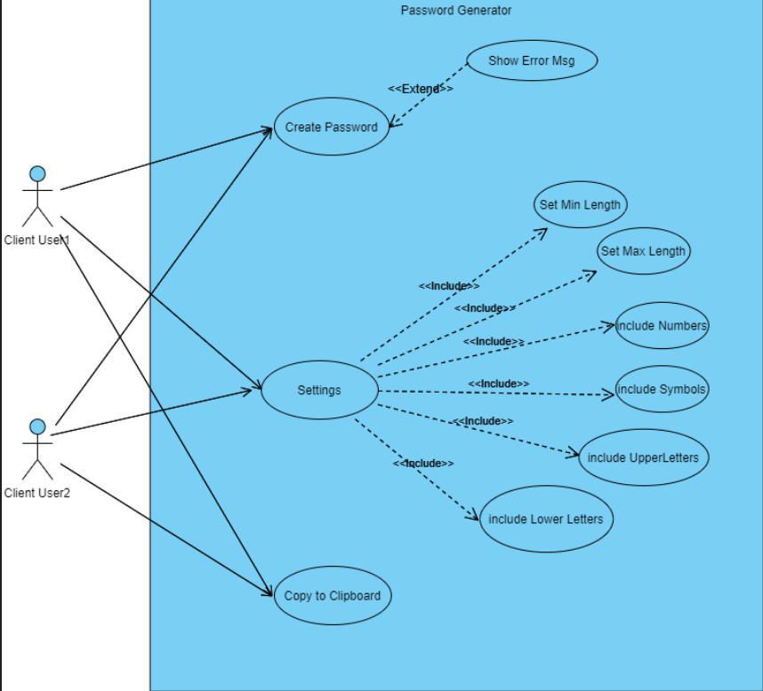

**Ethical and Cultural Impact**

To our knowledge, we are aware that there are lots of ways how these different groups of individual in different part of the world, may be able to get an access in one’s information and might have a negative effect to one’s information security.

Hence, as a software developer we know that there is a pressing need to improve the defenses. It is essential that we further enhance the security of our target users by understanding and analyzing how each user choose their passwords as this will give an important insights and will aid us on how to enhance the security of those users against password compromise attacks.

Having these to say, we all agreed to follow the best practices with regards to storing the information in an encrypted format and keep on working out how else we can improve the system.

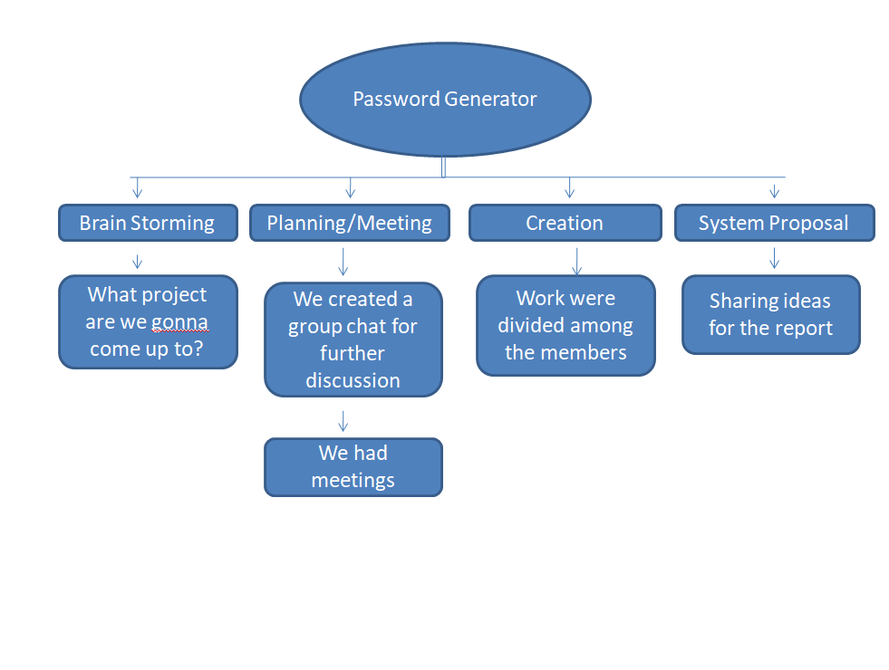**Project Timeline**

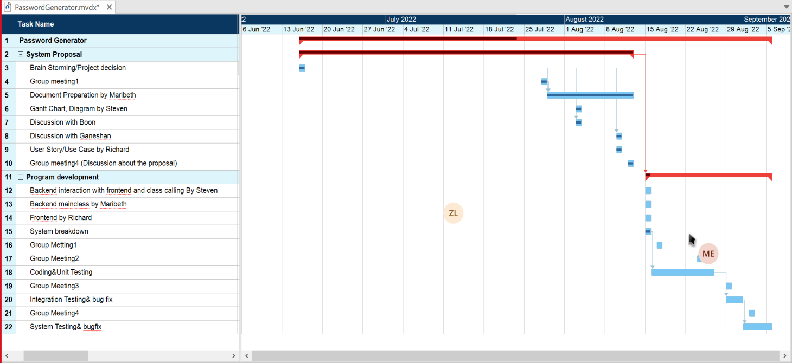**Gantt chart**

**About the project management methodology**

We will use the waterfall methodology to develop this software because the requirements of the project are explicit. This is a relatively simple system used to generate a password under some conditions. After we discussed the objective with the teacher, we know this software will only be used in certain circumstances when people want to create a random password. And this is a final project in this course, so it is unlikely to be changed in the future. Due to those reasons, we think the waterfall is an appropriate methodology for this project.*(Zhengwen Lei)*

**Table below depicts waterfall methodology**

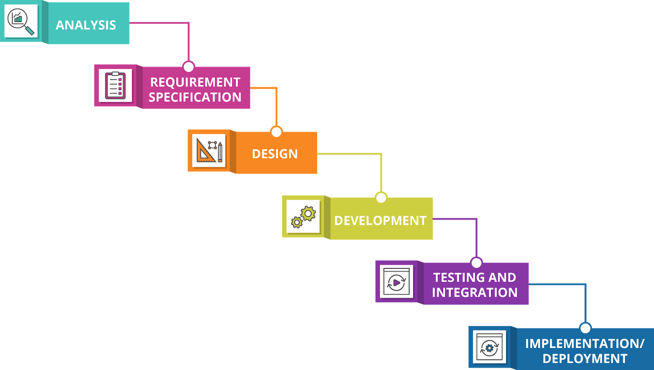

**Diagram**

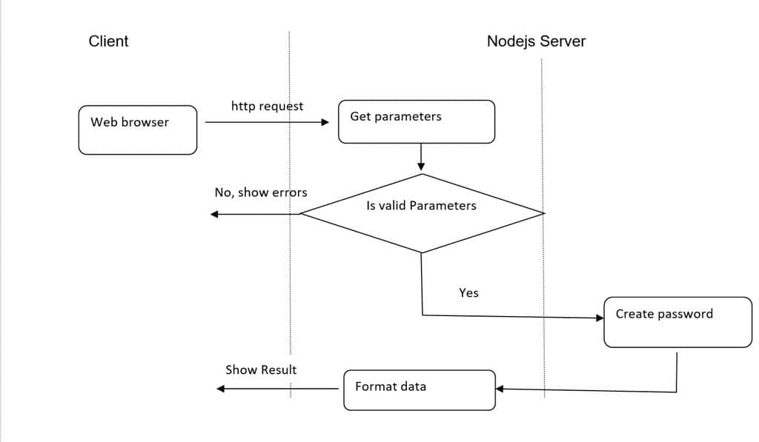

**References**

What is a Password Generator? [*https://www.techopedia.com/definition/31414/password-generator*](https://www.techopedia.com/definition/31414/password-generator)

Why should I use a Password Generator? *https://teampassword.com/blog/why-should-i-use-a-password-generator*

User Stories and Use Cases *SDLC – Define Phase: Use Cases 13th June 2022 MCSD51: Prepared by Boon*

Ethical and Cultural Impact[*https://arxiv.org/pdf/1712.08940.pdf%22%20%5Ct%20%22_blank*](https://arxiv.org/pdf/1712.08940.pdf%22%20%5Ct%20%22_blank) *,* [*https://www.sain.ca/publication/thorpePDFS/Do_Password_Managers_Nudge_Secure_Random_Passwords_SOUPS2022.pdf*](https://www.sain.ca/publication/thorpePDFS/Do_Password_Managers_Nudge_Secure_Random_Passwords_SOUPS2022.pdf) *,*[*https://www.researchgate.net/publication/309467190*](https://www.researchgate.net/publication/309467190)

Project Management Methodology, Water Fall Methodology Image from Google

# Variations From The Initial Proposal

Because all of the user cases and user stories are carefully considered before, we didn’t really change the initial proposal.

# Tools and Technologies Used (in alphabetical order)

* CSS
* Cookies
* EJS
* Express.js
* Gantt Chart
* GitHub Desktop
* HTML
* JavaScript
* Lucid Chart
* Node.js
* Notepad++ / Edit plus
* XAMPP - Apache

# SDLC

As planned during the proposal stage, we use the waterfall methodology in this project, and it fits well because the requirements are clear.

# Project timeline

We were unable to follow the planned timeline in the proposal because every team member was engaged in their own part time job. Besides, most of us didn’t have sufficient experience in programming and it cost us lot of time finding solutions.

However, we kept regular meeting in Microsoft teams, it helped us get to know others progress.

# Ethical and cultural impact

This is a practical app for generating appropriate password and doesn’t much involve in ethical and cultural impact.

As discussed in the Proposal, this project aims to enhance the security of our users against password compromise attacks.

For this reason, we all agreed to follow the best practices with regards to storing the information in an encrypted format and keep on working out how else we can improve the system.

# Selected Screenshots of the completed App

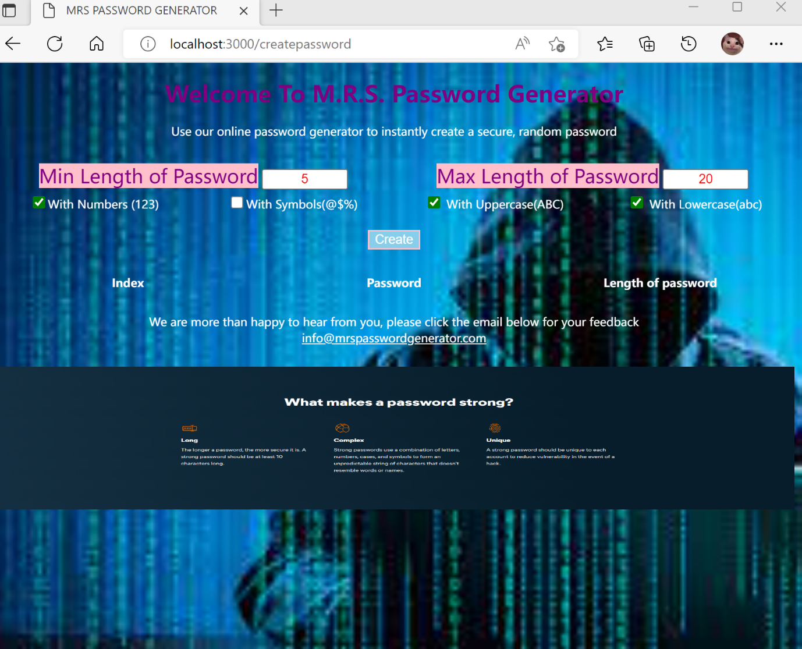

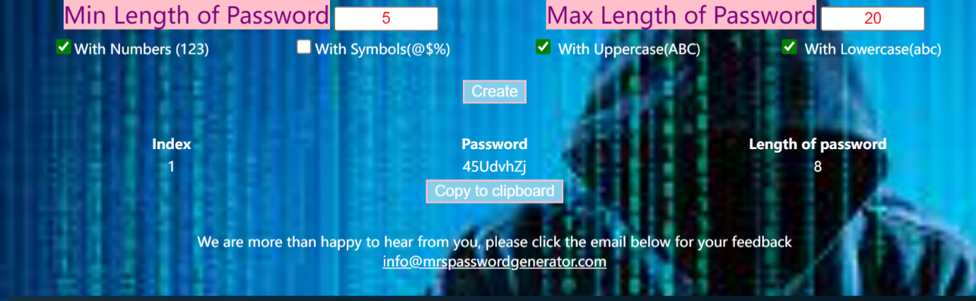

# Reflections

**Maribeth:** As I sit down to reflect on my learning journey at Future Skills Academy, I must say that it was a positive one. Working in a totally different field was such a challenge to begin with. I have no clue about the tools, modules and languages and even felt overwhelmed, finding out that we need to create a program as part of our project. Thankfully, I was put in a group where my team will always check if I needed help and has been very supportive from day 1 up to the final stage. We worked closely just to ensure that we are all in the same page. By doing this project, I gained the knowledge how to use basic CSS, HTML and JavaScript. I also learnt about User Story and Use Cases. It is no secret that there is much more to learn on my end. Learning environment is amazing; lecturers are very supportive and willing to extend help as much as they could.

**Richard:**

**Steven:** I worked in software development for many years when I was in China. Most of my jobs were developing small games in C++. I only have very basic knowledge about HTML and javascript. And I have never used Node.JS, Git hub, or Gannt charts before this class. By doing this project I get familiar with these tools. Besides, as a team leader for this project, I have to arrange our work reasonably. It also enhances my project management ability. Furthermore, one of my weaknesses is my English skills, by attending this class, my English has improved.

If I am to do this project again, I will combine it with password management. When users have created a password, they will have an opportunity to save it online with a particular website. And in the future, when the user logins and clicks a link in the software, it can automatically log in using a stored account and password. And this software would become an entrance for many other websites or apps. It also gives added value to this software.

**References**

Future Skills Academy. August 2022. JavaScript.

What is a Password Generator? (2022), [*https://www.techopedia.com/definition/31414/password-generator*](https://www.techopedia.com/definition/31414/password-generator)

Why should I use a Password Generator? (27.10.2022), *https://teampassword.com/blog/why-should-i-use-a-password-generator*

User Stories and Use Cases *SDLC – Define Phase: Use Cases 13th June 2022 MCSD51: Prepared by Boon*

Ethical and Cultural Impact (24.12.2017), [*https://arxiv.org/pdf/1712.08940.pdf%22%20%5Ct%20%22_blank*](https://arxiv.org/pdf/1712.08940.pdf%22%20%5Ct%20%22_blank) *,* [*https://www.sain.ca/publication/thorpePDFS/Do_Password_Managers_Nudge_Secure_Random_Passwords_SOUPS2022.pdf*](https://www.sain.ca/publication/thorpePDFS/Do_Password_Managers_Nudge_Secure_Random_Passwords_SOUPS2022.pdf) *,*[*https://www.researchgate.net/publication/309467190*](https://www.researchgate.net/publication/309467190)

Project Management Methodology, Water Fall Methodology Image from Google

<https://www.w3schools.com/cs/trycs.php?filename=demo_helloworld>

# Appendix: Code